**TSW-x60 - Sonos App - Getting Started**

Answer ID: 5773   |    Access Level: Privileged   |    Updated: 01/14/2019

|  |
| --- |
| **General Information & Updating Sonos App** |

* The full version of the Sonos App for Android is available on the TSW-560P, TSW-760, and TSW-1060.
  + The Sonos App is not supported on the TSW-560 (small screen size limits useability).
* TSW firmware packages include Sonos App updates, and must be kept up-to-date to ensure compatibility with the latest Sonos firmware & app updates.
* The Sonos app ***cannot*** be updated using the "Update" button encountered within the Sonos app
  + TSWs are only able to run apps that have been approved & tested by Crestron (Sonos & Zoom, as of January 2019)
    - The "Update" button in the Sonos app would usually launch the Google Play Store (not loaded / supported on TSWs).
    - To browse Apple Music in the Sonos app, login using [Sonos PC software](https://www.sonos.com/en-us/software/release/" \t "_blank) (as Apple Music app isn't loaded / supported on TSWs).
* TSW Sonos app updates are hosted on Crestron servers, after they've been tested & verified working.
  + TSWs automatically check Crestron servers at 2am (by default) for updates to the Sonos app.
  + Manual check / update can be performed two ways:
    - Text Console Command  **APPUPDATE SONOS**
    - TSW Setup Menu > About > Check App For Updates (button)  
      [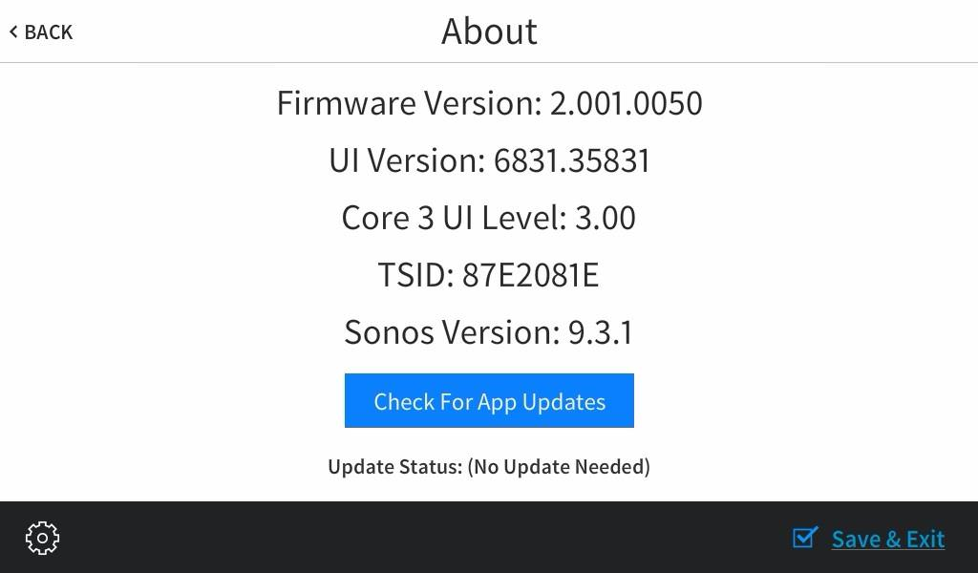](https://i.imgur.com/zwVcsII.jpg)

|  |
| --- |
| **Launching the Sonos App on TSW-x60 Touchpanels** |

There are two methods to launch the Sonos App from your panel project.

* **VTProE** - Use Button With Reserved Join *"Start SONOS"* (*28511*)
  + Use *"Home"* button on bezel to return to the panel project

[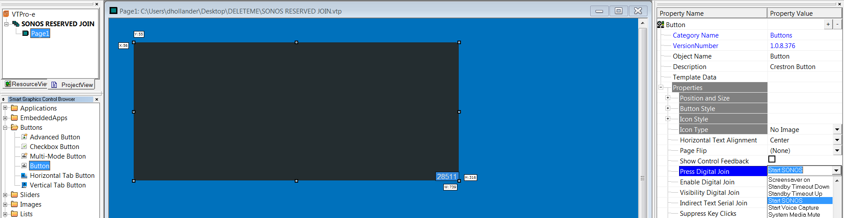](http://i.imgur.com/IVWm3UK.png)

* **SIMPL** - Use "App Control" Device Extender Signals
  + *<Start SONOS>* opens the Sonos app  
    Sonos Setup is launched if not yet configured/connected
  + *<Close Opened App>* closes the Sonos app
  + *<Close Opened App\_fb>* reports if Sonos app has been closed
  + *<Hide Opened App>* hides the Sonos app (continues to run in background)
  + *<Hide Opened App\_fb>* reports if Sonos app has been hidden

[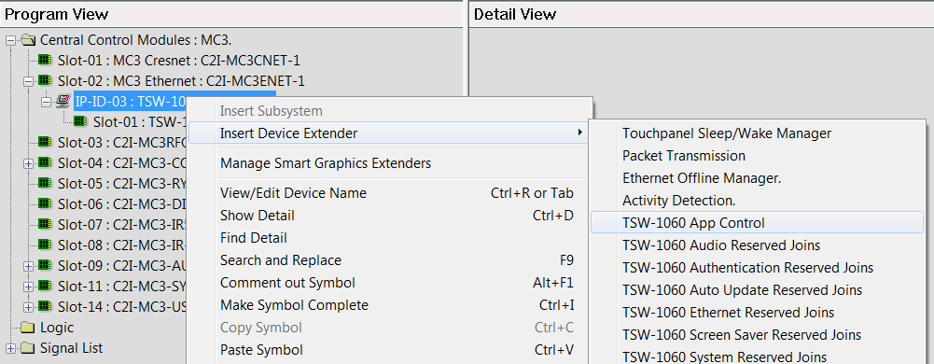](http://i.imgur.com/ZnJk0Ze.png)  
[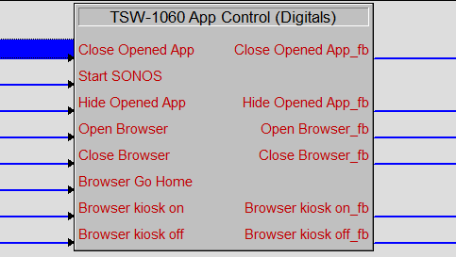](http://i.imgur.com/2ocMaxi.png)

|  |
| --- |
| **Hard Button Behavior When Sonos App Is Open** |

**When the Sonos App is open:**

* Power - Hides the Sonos App & fires its digital join
* Home - Hides the Sonos App (Does not fire its digital join)
* Lights - Hides the Sonos App & fires its digital join
* Up/Down - Doesn't affect Sonos App & fires their digital joins

This allows the user to maintain functionality of up/down buttons when the app is open - for things like lighting control, or even volume control (if the Sonos Aux Out goes to an AVR, for example).  
  
The Power and Lights buttons will return to the panel UI, but also fire their joins to potentially save the user an additional click - you can have the join jump them right to their respective page/subpage.  
  
This functionality is not extended to the Home button - when the Sonos App is open it behaves strictly like a "back" button. The panel must have returned to its UI project before the Home button will fire its digital join.